**Lab For Loop (Day-7)**

1. **Print the first 10 natural numbers using for loop.**

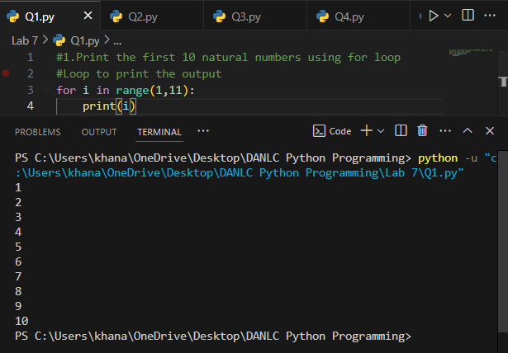

1. **Python program to check if the given string is a palindrome.**

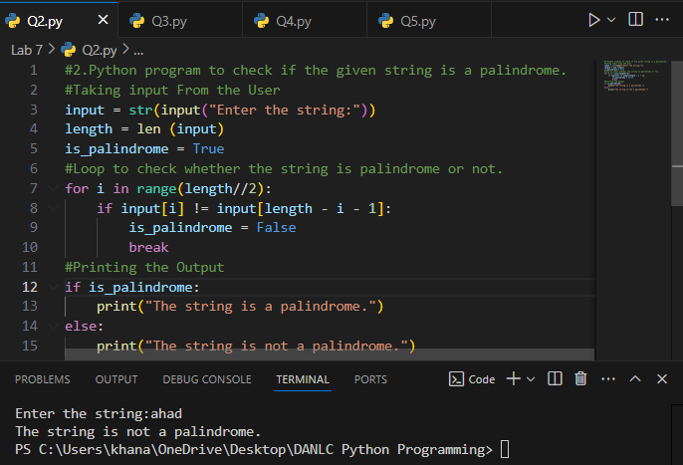

1. **Python program to check if a given number is an Armstrong number.**

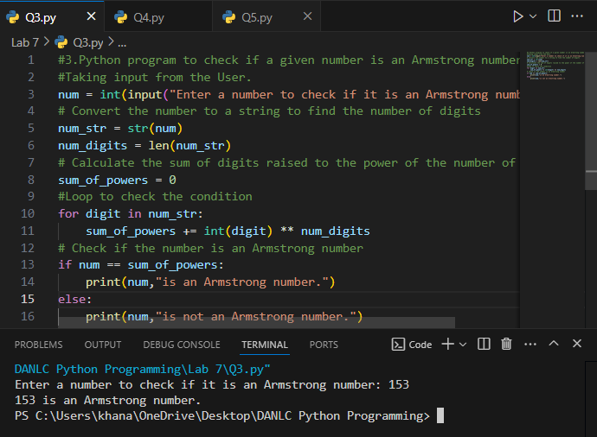

1. **Python program to get the Fibonacci series between 0 to 50.**

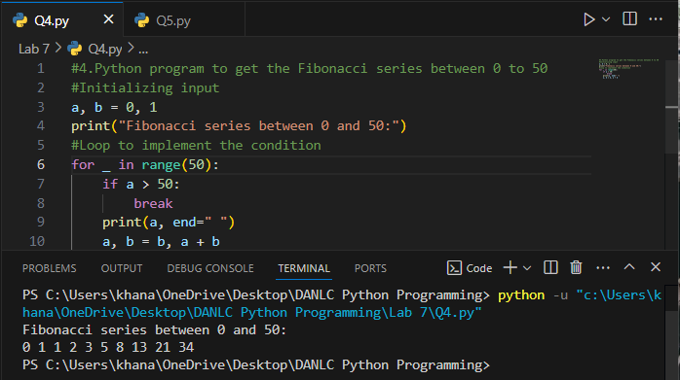

1. **Python program to check the validity of password input by users.**

